Network Channel and Virtual Host in Weblogic

Admin Server listens on Port: 8001

Manager Server Listens on Port: 8003

Benefits application listens on Port: 8003

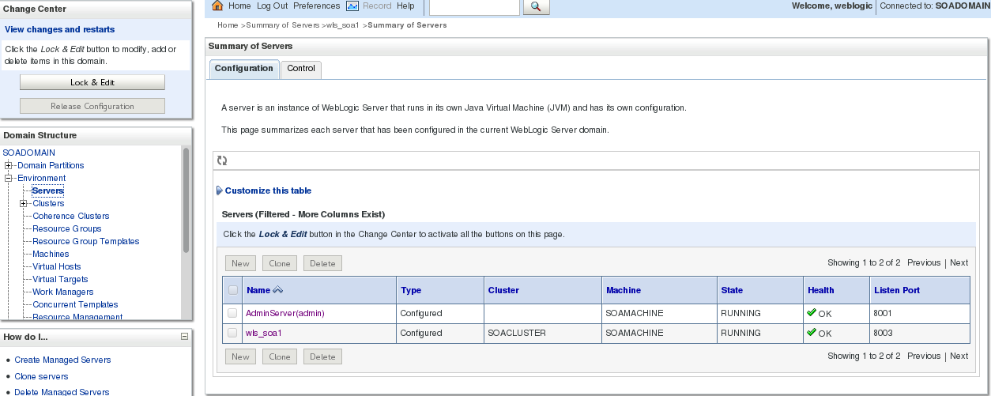

Create Network Channel for Managed Server

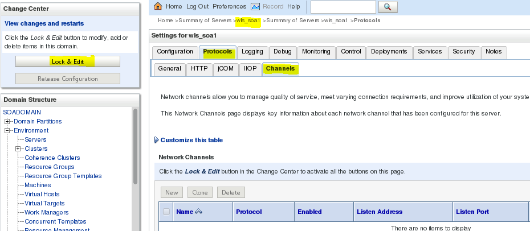

Click New

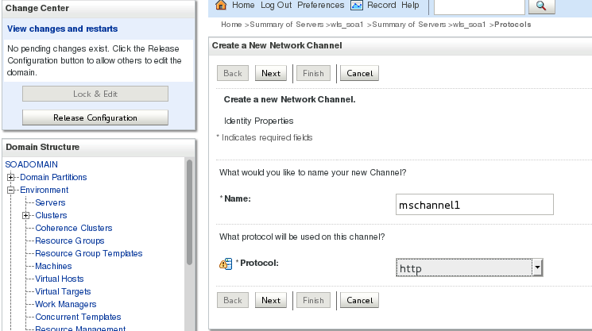

Click Next

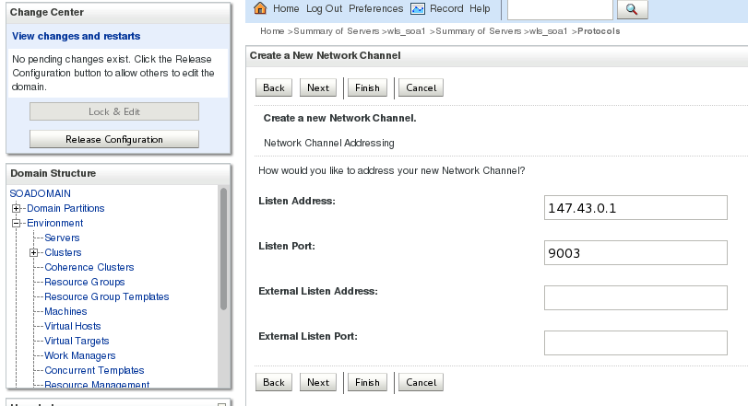

Click Next

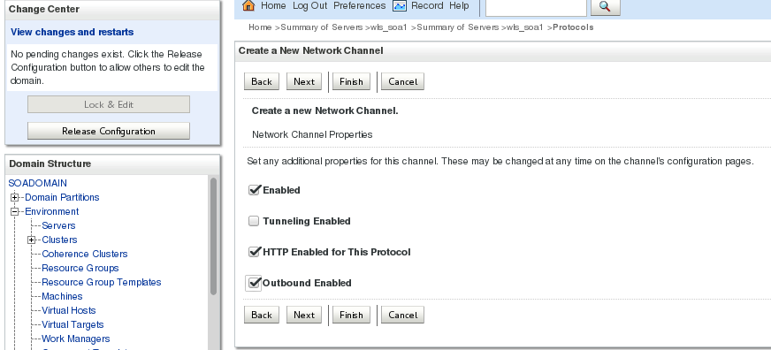

Click Next

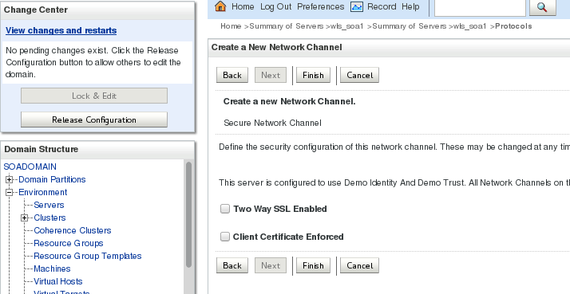

Click Finish



Activate changes

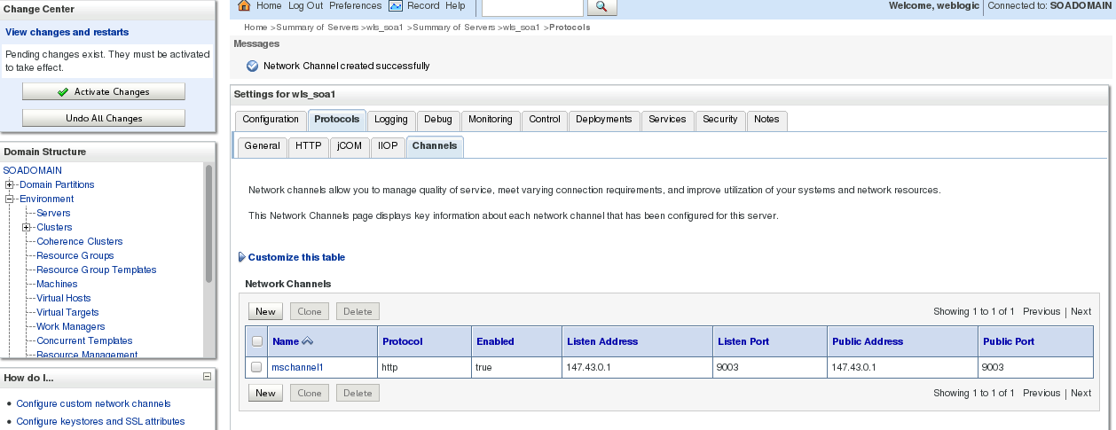

After creating Network channel on MS, applications are listening to new port 9003

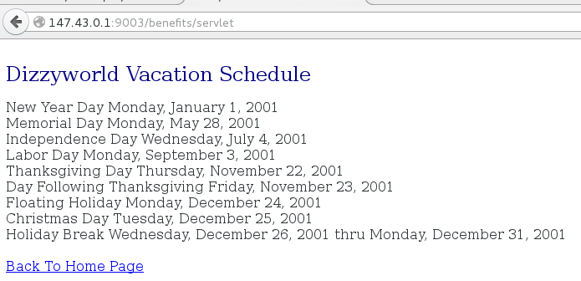

Now Disable the Network channel and see whether applications are listening on new port 9003

Disabled the Network channel

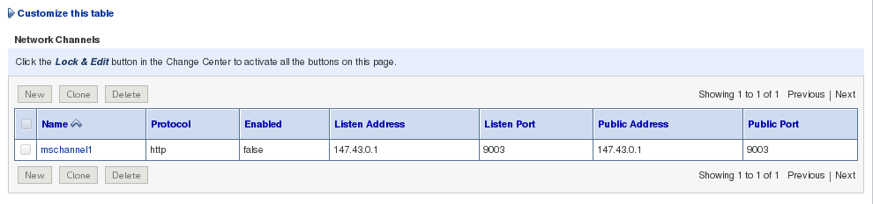

Applications are not accessible

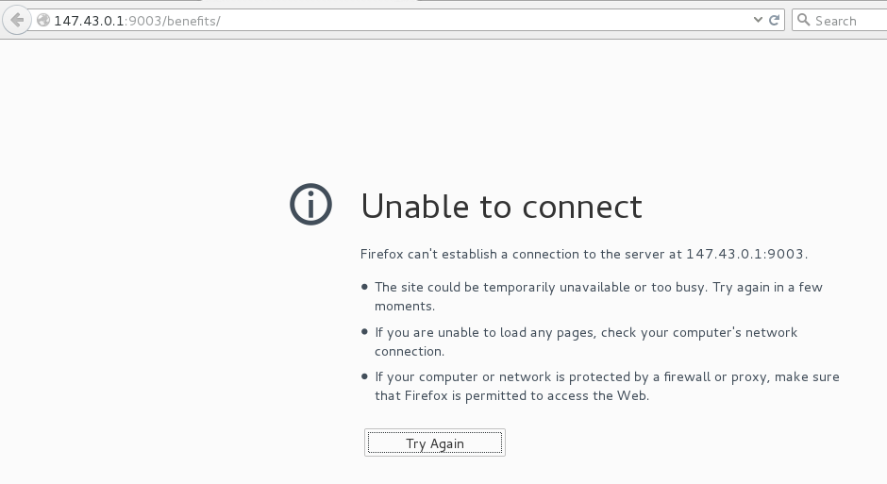

Create Domain Wide Admin Port

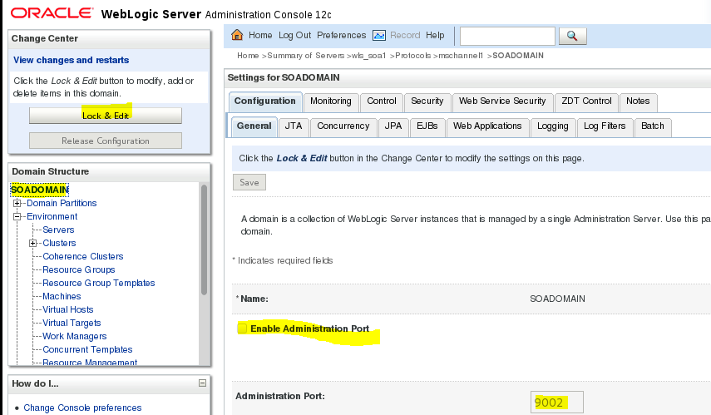

Login admin console with port 9002

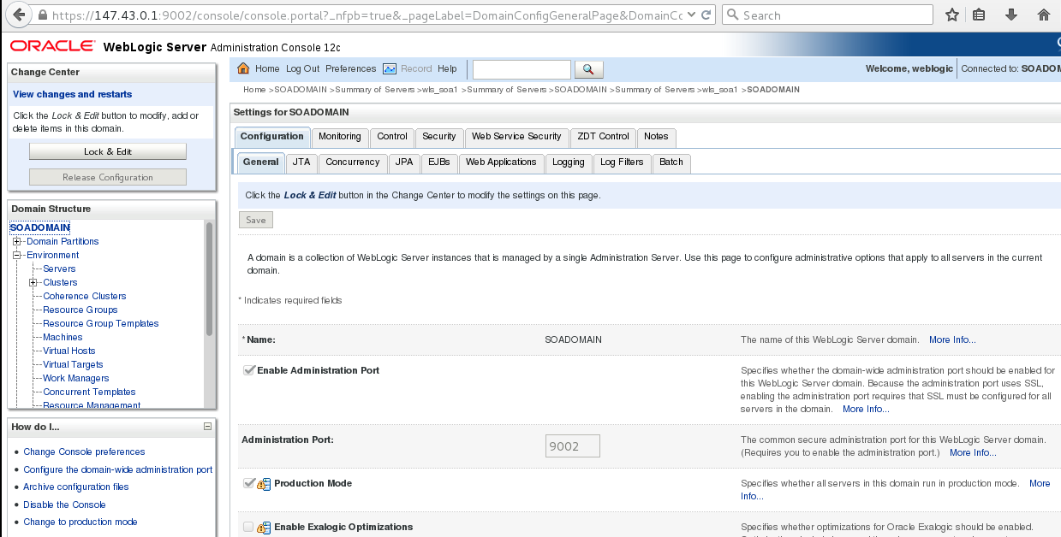

Set local admin port overwrite in managed servers

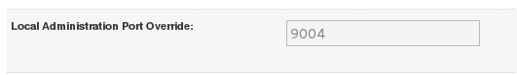

Start the application in admin mode and see whether it is accessible via admin port (9004)

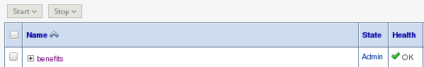

Now access via admin port 9004

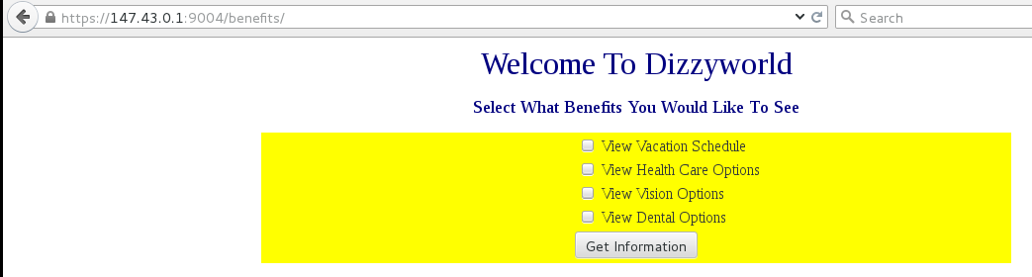

Virtual host

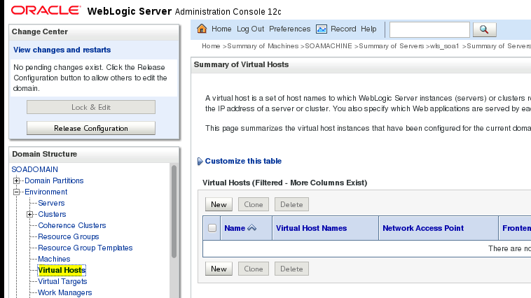

Click New

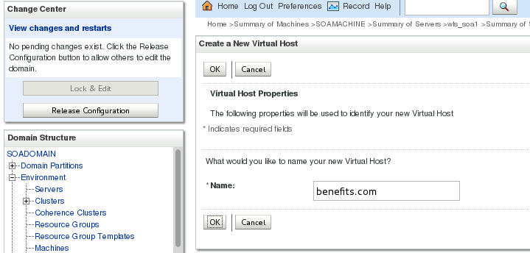

Assign the virtual host to clusters

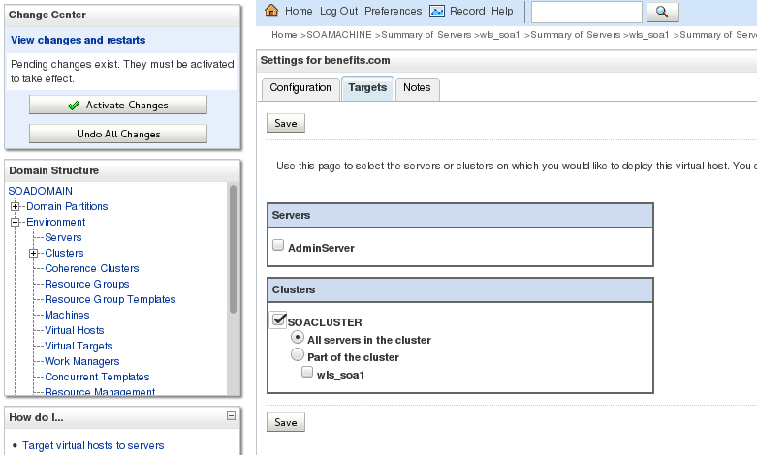

Add the virtual host entry in /etc/hosts

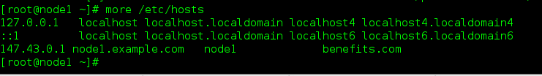

Deploy the application to virtual host

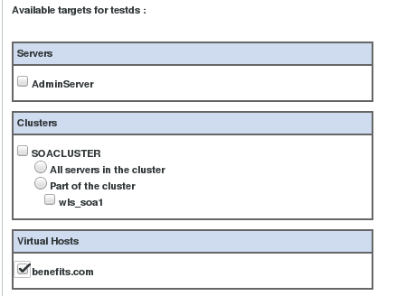

Access the application via virtual host

